USER-DRIVEN LIBRARY MANAGEMENT SYSTEM

PROJECT OPERATIONS
The Library Management System automates the basic library functions to aid in the day-to-day operations of a library. It supports functions such as issue, return, the very basic functions of searching for a particular book, etc.
It also maintains data about books, teachers, students records that are required during various library operations. The software aims to make the system user friendly and efficient.
The system prompts users to enter password to enter into the system and allows entry for three types of users and provides them functions of:-
- Library staff :- A user can enter as library staff and provide functions like addition/modification of new books, addition of new members, lend /return books etc. The details of these functions are:-
(i) ADD BOOK: This operation is performed to add a new book information to the library system. It prompts the user to enter details such as ISBN, name of book, author of book, number of copies, book is reserved or not etc.
(ii) SEARCH BOOK: This operation allows users to search for a particular book using its ISBN number and provides the entire details of the book as name of book, author name, issued, reserved etc.
(iii) MARK RESERVED: This operation allows users to mark a book as reserved or unreserved using its ISBN number.
(iv) MODIFY BOOK: This operation is performed to modify the information related to book as book title, author, number of copies etc.
(v) LEND BOOK: This operation allows staff to issue a book to registered members with return date after 14 days from issuance.
(vi) ADD MEMBER: This operation allows staff to add new members to the library system and prompts for details of user as name, address, phone number etc.
(vii) RETURN BOOK: This operation allows staff to get a return book from the user and make it available for other users by clearing issued and return date fields.
(viii) VIEW EVENTS: This operation allows library staff to view all the events from other users and suppliers such as requests for membership and selling the book etc.
(ix) DELETE: This operation allows library staff to delete the events, books and members in the system.
2. Users (Students/Teachers): A user can enter as a normal user i.e. either a student or teacher. These users have access to operational aspects of the system with the following operations:-
(i) SEARCH BOOK: This operation allows users to search for a particular book using its ISBN number and provides the entire details of the book as name of book, author name, issued, reserved etc.
(ii) APPLY FOR MEMBERSHIP: This operation allows users to apply for library membership by providing their user types, name, address, phone number etc.
(iii) BORROW BOOK: This operation allows users to request issuance of book by providing isbn and borrower id.
(iv) RETURN BOOK: This operation allows users to request return of book by providing isbn and borrower id.
3. Suppliers: A user can enter as a book supplier to provide quotations of books. The users will be allowed to perform following operations:-
(i) SEARCH BOOK: This operation allows users to search for a particular book using its ISBN number and provides the entire details of the book as name of book, author name, issued, reserved etc.
(ii) SELL BOOK: This operation allows users to sell a book by providing the details of book like title, author, price etc.

DATABASE ARCHITECTURE
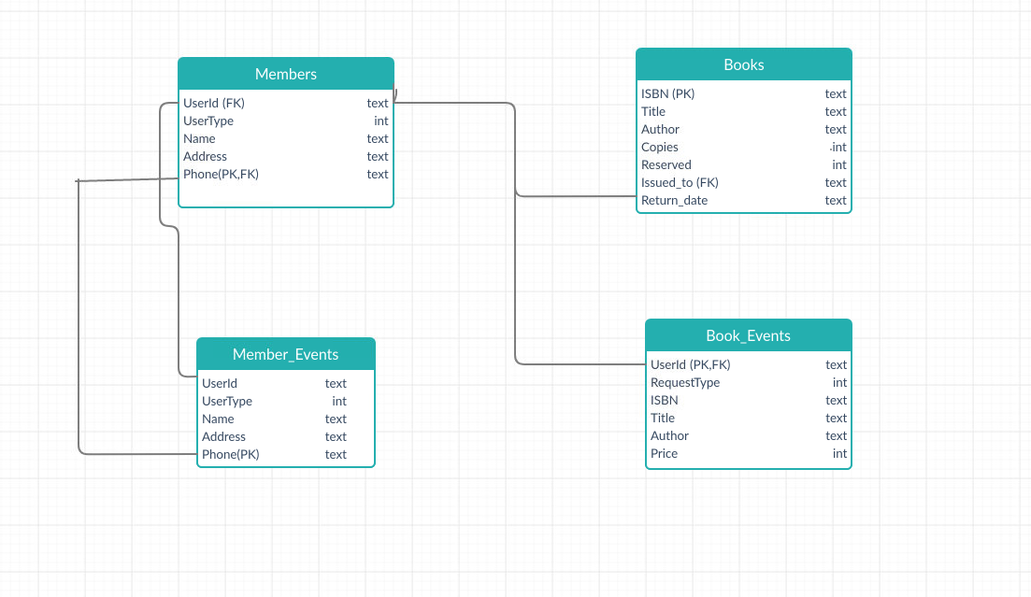
- Users/Suppliers requests for membership are placed in Member_Events table where a unique UserId is issued to users.
- Library staff adds new members to the library system in the Members table based on applications of memberships.
- Suppliers provide quotations to sell the book and that information is stored in Book_Events.
- In addition to quotation requests, requests regarding borrow and return of books are also placed in Book_Events.
- Library staff can add books to the Books table providing details about number of copies, issued, reserved status etc.
- The information regarding successful issuance and return of book is also maintained by library staff in the Books table.

ACCESS RIGHTS ON TABLES FOR DIFFERENT ACTORS

 | Member_Events | Book_Events | Member | Book
Library Staff | Read/Write | Read/Write | Read/Write | Read/Write
User | Read/Write | Read/Write | Read | Read
Supplier | Read/Write | Read/Write | Read | Read

INPUT VALIDATIONS
The system performs the user input validation in the form of:-
- Checks that no field should be left blank for which user is prompted.
- The options chosen are there in the manual provided.
- Check for a valid phone number.

TEST CASES
The system executes some of the test cases taking input from file and redirecting output to another file using Makefile. “make” command runs all the tests and checks if they are passed based on the output.

WORKFLOW SEQUENCE DIAGRAM
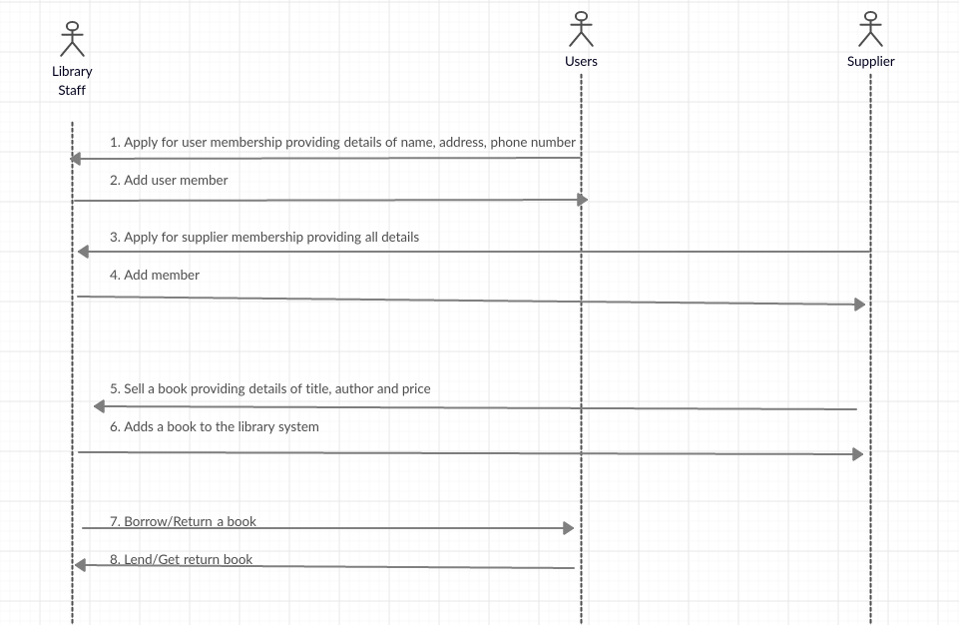
- Users apply for the membership in the form of student/teacher.
- Library staff adds a member to the library system.
- Suppliers apply for membership providing details.
- Library staff adds suppliers as members.
- Supplier places a request to sell a book with details of the book such as title, author, price etc.
- Library staff look at the quotations and proceed to add the books.
- Users request to borrow/return a book by providing its ISBN.
- Library staff lend/get returned books from the users.

